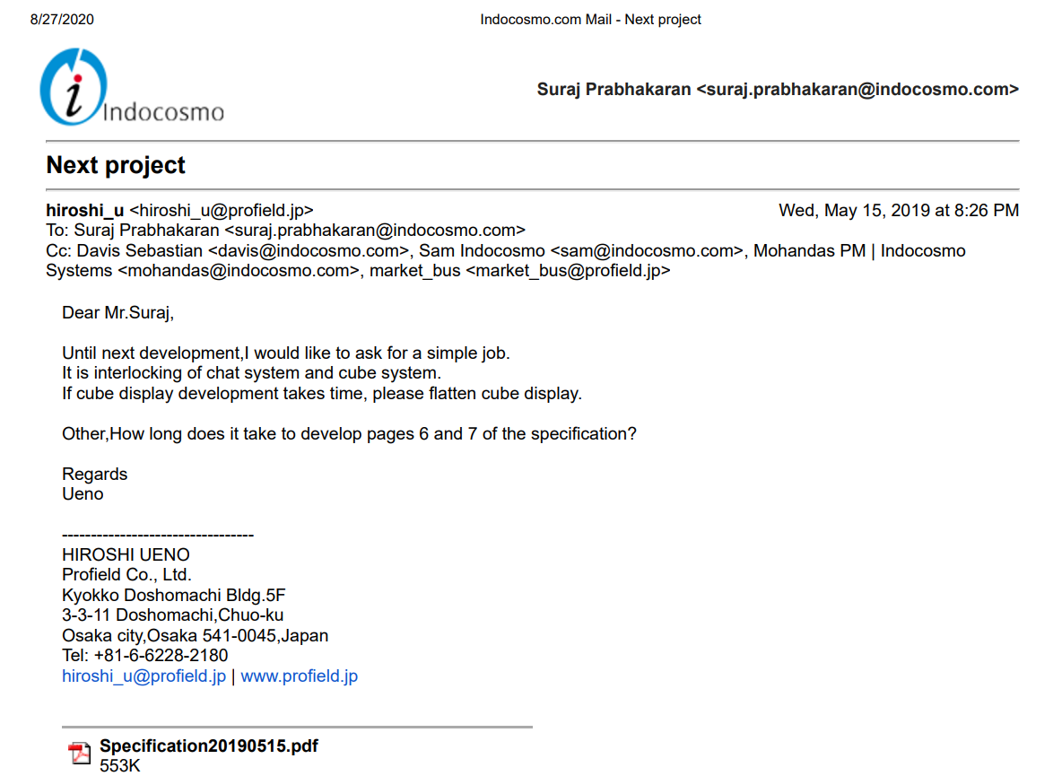
Document password: indocosmo2019

Queries and clarifications answered

